SENIOR FIVE TERM 3 CHEMISTRY NOTES 2026

TOPIC 1/2: Organic Chemistry I PART 2
Topic competency: The learner analyses the structures, functional groups, and reactivity of organic compounds, and applies knowledge of organic reactions and organic reaction mechanisms to synthesise organic molecules.

Alkylhalides (R-X, X = Cl, Br, I)
These are compounds with atleast one halogen atom attached to the parent chain.
Classification of mono substutued alkylhalide
As seen earlier, they are classified like alcohols.
They are three classes of alkylhalide depending on the number of alkyl groups attached to a carbon atom that carry a halide.
- Primary alkylhalide have one alkyl group on the carbon atom that carries a halide.
Examples
H H H H
  - Cl H C Br
C
C
C
C
H
H H | H H H
Chloroethane | 1-Bromopropane
- Secondary alkylhalide have two alkyl groups attached to a carbon atom that carry a halide
Examples
H H H H H H H
  - C H H CH
C
C
C
C
C
H Br H  2-Bromobutane | H | H | Cl H  2-chloropropane

- Tertiary alkylhalide
Tertiary alkylhalide have three alkylgroups attached to the carbon atoms that carry OH group Examples
H CH₃ H H CH₃ H
H C H H
C
C
C
C
C
H Br H H I H
2-bromo-2-methylbutanane 2-iodo-2-phenylpropane

Preparation of alkylhalide
1. By reacting alkenes with halogenhalide
Example
HCl CH₃CHCH₂
C
H
2
C
H
3
C
H
Cl H
Mechanism
Remember: the reaction occurs at the double bond and hydrogen atom goes to a carbon that carries highest number of hydrogen atoms.
H H H
CH₃C CH₂CH₂
C
H
3
C
C
H
2
H
C
l
C
H
3
C
C
l
C
l
H
H

Trial 1
Complete and write a mechanism for the following reactions (mark yourself after)
(a) CH CH CH HBr
3
2
C
H
2
C
H
C
H
2
HI
(b)

Solution to Trial 1
In these reactions, the double bond breaks and hydrogen halide adds itself a cross the carbon atoms that were forming the double bond. Hydrogen atom adds to a carbon atom the carries the highest number of hydrogen atom of those that form a double bond. Make sure you account for the charges.
H
(a) CH₃CH₂CHCH₂ ^{HBr} CH₃CH₂CCH₂
Br H
Mechanism
CH₂
C
H
3
C
H
2
C
C
H
2
H
B
r
H
C
H
3
C
H
2
C
C
H
2
H
H
B
r
C
H
3
C
H
2
C
B
r
H
H

H
CH₂
C
H
C
H
2
H
I
C
I
(b)
H
Mechanism
C
H
2
H
I
H
C
H
2
H
H
I
C
H
2
I
H
H
C
C
C

2. By reacting chlorine gas or bromine with alkanes. The reaction occurs in the presence of u.v light. This was dealt with when dealing with reactions of alkanes.

Trial 2
Complete the following equation and write a mechanism
(a) CH +Cl u.v-light
4
2
C
H
3

+

B
r
2
u
.
v
-
l
i
g
h
t
(b)

Solution to Trial 2
These reactions follow a free radical mechanism, be keen to observe the initiation and formation of free radicals as the reaction proceeds. Every dot (un paired electron) must be accounted for.
(a) CH4 +Cl2 u.v-light CH3Cl
Methane chloromethane
Mechanism
Cl₂ u.v-light 2Cl
chlorine radical
H₃C H +Cl H₃C + HCl
methyl radical
H
3
C

+

C
l
2
H
3
C
C
l
+
C
l

(
b
)
C
H
3

+

B
r
2
u
.
v
-
l
i
g
h
t
C
H
2
B
r
Bromine radical
M
e
c
h
a
n
i
s
m
B
r
2
2
B
r
u
.
v
-
l
i
g
h
t
H

+
C
l
C
H
H
C
H
+

H
B
r
C
H
H
C
H
H
B
r

+

B
r
+

B
r
2

H
3. By reacting alcohols with

(a) Phosphorus halide Examples 1
PCl₅
- CH₃CH₂OH CH₃CH₂Cl
- CH₃CHCH₃ P B r 3 CH₃CHCH₃

OHBr

(b) With HX (X= Cl, Br, I)
HI and HBr react readily with alcohols but the reaction of HCl is catalyzed with anhydrous zinc chloride. The mechanism of the reaction depends on the class of alcohol. Though secondary alcohols react like either primary or tertiary alcohols.

Example 2
Primary alcohol
CH₃CH₂OH + HI CH₃CH₂I + H₂O

Mechanism
H H
C
H
3
C
H
2
O
H
H
I
H
H
H
C
C
O
H
2
I
C
H
3
C
H
2
I

Tertiary alcohol
CH₃ CH₃
H3CCH₃ HBr CH₃
C
C
H
3
C
OH Br

Mechanism
CH₃ CH₃ CH CH
C
C
H
3
H
3
C
O
H
C
3
C
H
3
H
3
C
B
r
C
C
H
3
H
3
C
O
H
2
C
3
C
H
3
H
3
C
H
B
r
B
r

Trial 3
Complete and write a mechanism, thereafter mark yourself
CH₂OH + HI
(i)
(ii) C (CH₃)₂ + HBr
OH

Solution to trial 3
CH₂OH + HICH₂I + H₂O
(i)
Phenylmethanol Iodophenylmethane

Mechanism
Note that phenylmethanol is a primary alcohol
C
H
2
O
H
H
I
H
H
C
O
H
2
I
C
H
2
I
-
H
2
O

(ii) C (CH₃)₂ + HBr C (CH₃)₂
OH Br
2-Phenylpropan-2-ol
Mechanism
Please note that 2-phenylpropan-2-ol is a tertiary alcohol
C
C
H
3
C
H
3
O
H
C
C
H
3
C
H
3
B
r
C
C
H
3
C
H
3
O
H
2
C
C
H
3
C
H
3
H
B
r
B
r

(c) Reaction of HCl with alcohols is catalyzed by anhydrous zinc chloride because HCl bond is strong.
Primary alcohol does not react, secondary alcohol reacts slowly, and tertiary alcohol reacts faster.

Example 3
HCl/ZnCl
Mechanism | 3 3
(CH₃)₃COH ² (CH ) CCl
+
(CH₃)₃C (CH₃)₃C ₂ (CH₃)₃C (CH₃)₂CCl
O
H
+
O
H
:
H
C
l
Z
n
C
l
2
:
C
l
-

(d) Reaction of alcohol with KX (X= Cl, Br, I)
The mechanisms depend on the class of alcohols. The mechanism of secondary alcohols is either similar to those of primary or tertiary alcohols
Primary alcohol
-
CH₃CH₂OH + KCl CH₃CH₂Cl + OH
Mechanism
CH₃CH₂Cl + O- H
H
H
H
H
C
C
O
H
C
l
H

Tertiary alcohol
KBr
(CH₃)₃COH (CH₃)₃CBr
Mechanism
+
(CH₃)₃C (CH₃)₃C (CH₃)₂CBr
:
B
r
-
O
H

Chemical properties

(a) Formation of alkenes
Alkylhalides react with hot alcoholic potassium hydroxide to form alkenes. The mechanism depends on the class of alkylhalide but mechanism of reaction for secondary alkylhalide is similar to that of the primary or tertiary alkylalide. These reactions were also considered when we dealt with preparation of alkene

Example 4

ethanol/KOH CH2=CH2
CH3CH2Cl
Chloroethane ^{reflux} Ethene

Mechanism

Ethanol  Then | H | H
CH₃CH₂OH + OH CH₃CH₂O + H₂O
C
H
2
=
C
H
2
H
C
C
H
H
C
l
C
H
3
C
H
2
O
Example 5
CH₃CH₂CH₂Br  1-Bbromopropane | CH₃CH₂OH/OH  heat | CH₃CH=CH₂  Propene

Mechanism

CH₃CH₂OH + OH CH₃CH₂O + H₂O Ethanol
Then H H

C
H
2
=
C
H
2
H
3
C
C
C
H
H
B
r
C
H
3
C
H
2
O

CH
3

Trial 4
Complete and write a mechanism
EtO- / EtOH
CH₂CH₂Cl
Reflux

Solution to trial 4
CH2CH2Cl CH=CH2
R
e
f
l
u
x
E
t
O
-
/
E
t
O
H
H
C
C
H
H
H
P
h
e
n
y
l
e
t
h
e
n
e
M
e
c
h
a
n
i
s
m
C
l
C
H
=
C
H
2
E
t
O

- Secondary alkyl halides undergo the same mechanism as primary alkyl halides or that of tertiary alkyl halides
- Tertiary alkyl halides undergo a mechanism called E1 or elimination unimolecular because a water molecule is eliminated and the slowest step involves one molecule only.
Example
H
3
C
C
C
H
3
C
H
3
I
C
H
3
O
/
C
H
3
O
H
h
e
a
t
H
2
C
C
C
H
3
C
H
3
2
-
I
o
d
o
-
2
-
m
e
t
h
y
l
p
r
o
p
a
n
e
2
-
m
e
t
h
y
l
p
r
o
p
e
n
e

Mechanism
H
2
C
C
C
H
3
C
H
3
I
H
3
C
C
C
H
3
C
H
3
H
3
C
C
C
C
H
3
H
H
H
C
H
3
O

Trial 5
Complete and write a mechanism
C
C
H
3
C
H
3
C
l
E
t
O
/
E
t
O
H
h
e
a
t

Solution to trial 5
C
C
H
2
C
H
3
C
C
H
3
C
H
3
C
l
E
t
O
/
E
t
O
H
h
e
a
t

Mechanism
C
l
C
C
H
3
C
H
3
C
C
C
H
3
H
H
H
C
C
H
2
C
H
3
E
t
O

(b) Reaction of alkyl halide with alkalis (NaOH or KOH)
Alkyl halides react with hot alkalis to form alcohols. The secondary alkyl halides react by either mechanism of primary or tertiary alkyl halides. Primary alkyl halide

CH₃CH₂Cl + KOH CH₃CH₂OH + Cl⁻
Mechanisms
H
CH₃CH₃CH₂OH
H
C
O
H
C
l
s
l
o
w

The mechanism is described as SN² (substitution nucleophilic bimolecular) because a nucleophile (-OH) substitutes a halide atom and the slow step in the reaction involved two species i.e. –OH and alkylhalide.
(CH3)3CBr KOH (CH3)3COH
Mechanism
slow +
(CH₃)₃C (CH₃)₃C (CH₃)₂COH
B
r
:
O
H
-

Trial 7
Complete and write a mechanism, thereafter mark yourself
CH₂Cl + NaOH
(i)
(ii) C (CH₃)₂ + KOH
I

Solution to trial 7
CH₂Cl + NaOHCH₂OH + Cl⁻
w
a
r
m
(i)
Chlorophenylmethane Phenylmethanol

Mechanism
Note that chlorophenylmethane is a primary alkyl halide
H
H
C
O
H
C
H
2
O
H
-
C
l
C
l

(ii) C (CH3)2 + NaOH C (CH3)2
w
a
r
m
I OH
2-Iodo-2-phenylpropane 2-phenylpropan-2-ol

Mechanism
Note that 2-iodo-2-phenylpropane is a tertiary alkyl halide
CH₃ CH CH
C
3
O
H
C
C
H
3
C
3
C
H
3
O
H
I
CH₃

(c) Reaction alkylhalides with potassium cyanide
Alkyl halides react with potassium cyanide to form nitrile. This reaction is important because it increases the carbon chain by one carbon atom. Primary alkyl halides undergo SN² while tertiary alkyl halides undergo SN¹ mechanism whereas secondary alkyl halides undergo either mechanism.
Examples 7
- CH₃CH₂Cl + KCN CH₃CH₂CN + Clchloroethane

Mechanism (note that chloroethane is a primary alkyl halide)
CH₃CH₃CH₂CN
H
H
C
C
N
C
l
s
l
o
w

- (CH₃)₃CBr ^{KCN} (CH₃)₃CCN
2-bromo-2-methylpropane

Mechanism (2-bromo-2-methylpropane is tertiary alkyl halide)
slow +
(CH₃)₃C (CH₃)₃C (CH₃)₂CCN
:
C
N
-
B
r

(d) Coupling reaction
Two alkyl halides couple in presence of sodium and dry ether or zinc-copper couple to form alkane of twice the number of carbon atoms as the parent alkyl halide.
Na, dry ether CH₃CH₂ CH₂CH₃ 2CH₃CH₂Cl
2CH3CH2CH2Br Na, dry ether CH₃CH₂CH₂ CH₂CH₂CH₃

(e) Formation of Gridnard’s reagent
Alkyl halides react with magnesium in presence of dry ether to form compound called Gridnard’s reagent.

Example 8
dry ether
CH₃CH₂Cl + Mg CH₃CH₂MgCl
Generally
RX + Mg dry ether RMgX
Gridnard’s reagents are important synthetic molecules that enable us to increase the parent carbon chain by unlimited number of carbon atoms in synthesis.

- Gridnard’s reagent reacts with carbon dioxide to produce carboxylic acid. The parent chain increase by one carbon atom.
O
R
C
O
RMgX + CO₂ COMgX ^{H+} OH
d
r
y

e
t
h
e
r
R
Example
O
CH3CH2MgCl + CO2 dry ether CH₃CH₂COMgCl H⁺ CH₃CH₂COOH

- Gridnard’s reagent reacts with methanal to produce primary alcohols. The parent chain increase by one carbon atom.
H
R
C
H
d
r
y

e
t
h
e
r
R
H+
RMgX + HCHOCOMgXOH
H H

Example 9
H H
H+
d
r
y

e
t
h
e
r
C
H
3
CH₃MgBr + HCHO COMgBr CH₃C OH
H H
(iii) Gridnard’s reagent reacts with aldehydes to produce secondary alcohols.
R' R'
H+
d
r
y

e
t
h
e
r
R
RMgBr +R'CHO COMgBr CH₃C OH
H H

Example 10
CH₃CH₂ H
H+
d
r
y

e
t
h
e
r
C
H
3
CH₃MgBr +CH₃CH₂CHO COMgBr CH₃C CH₂CH₃

H OH
(iv) Gridnard’s reagent reacts with ketones to produce secondary alcohols.
R"R' R'
H+
d
r
y

e
t
h
e
r
R
RMgBr +R'CO COMgBr CH₃C OH
R" R" Example
CH₃ CH₃CH₂ CH3
H+ CH₃MgBr +CH₃CH₂CO COMgBr CH₃C CH₂CH₃
d
r
y

e
t
h
e
r
C
H
3
CH₃ OH

Uses alkyl halides in industrial processes
- Solvents: They are used as solvents in chemical reactions and for cleaning and degreasing, especially for non-polar compounds.
- Refrigerants and propellants: Some alkyl halides, like CFCs, were historically used as refrigerants and aerosol propellants.
- Chemical synthesis: They are crucial intermediates in the production of a vast number of other compounds, including pharmaceuticals, pesticides, and polymers like polyvinyl chloride and Teflon.
- Flame retardants: Certain alkyl halides, particularly those containing bromine and fluorine, are used in fire retardants and fire extinguishers.
- Cleaning agents and other products: They are used in commercial cleaning agents, paint removers, and other specialty chemicals.

Environmental damage caused by alkylhalides:
- Ozone depletion: Chlorofluorocarbons (CFCs), a type of alkyl halide, are responsible for destroying the ozone layer.
- Global warming: Some volatile alkyl halides act as greenhouse gases with a high global warming potential.
- Pollution: Many halocarbons are serious pollutants that can persist in the environment. For example, DDT, an aryl halide, is not biodegradable and can harm the ecosystem.
Human health risks due to alkylhalides:
- Some alkyl halides can be toxic, and their use requires careful handling and risk mitigation.
Benefits of alkylhalides in medicine:
- The pharmaceutical industry uses alkyl halides to synthesize medicines. Approximately 20% of small molecule pharmaceuticals and 30% of all chemicals contain a halogen.
- Some alkyl halides are used as anesthetics.

Benzene
Chemical formula: C₆H₆.

Structure
Benzene is a cyclic compound with delocalized conjugated double bonds, i.e. the double bond is free to shift from one place to another through the whole molecule.

HH ororor
C
C
C
C
C
C
H
HH
H
Effect of delocalization of double bond in to the structure of benzene.
- Benzene ring is very stable that it is preserved in most chemical reaction, that is, it’s is generally unreactive towards electrophilic reagents.
- The six carbon-carbon bonds in the benzene are equal in length (i.e. 1.39Å) intermediate between the carbon-carbon double bond (1.34 Å) and carbon-carbon single bond (1.54 Å)

Physical properties
- It is a colorless with a characteristic aromatic smell.
- It is insoluble in water but soluble in organic solvents and its self is a good solvent.
- It burns with a smoky and luminous flame

Industiral preparation
Benzene is obtained by catalytic dehydration of hexane (from petroleum)
CH₃CH₂CH₂CH₂CH₂CH₃
P
t
P
t
h
e
a
t
h
e
a
t

Chemical properties
Benzene is not easily attacked by electrophilic reagents. In its reactions, benzene undergoes mostly electrophilic substitution reaction in which an electrophile substitutes a hydrogen atom, rather than addition reactions in which the benzene ring system would be destroyed.
Reactions

1. Combustion
Benzene reacts with oxygen to form carbon dioxide and water only.
2C₆H₆ + 15O₂ 12CO₂ + 6H₂O

In insufficient oxygen benzene is oxidized to water and carbon producing a smoky flame (test for aromaticity)
2C₆H₆ + 3O₂ →6C(s) + 6H₂O

2. Catalytic hydrogenation
Benzene undergoes catalytic hydrogenation to cyclohexane
H
2

/
P
t
heat
Benzene Cylohexane
The heats of hydrogenation and combustion of benzene are lower (by 36kcal/mole) than expected. In other words, benzene is more stable by 30kCal than we would expect cyclohexatriene to be. The 36kCal is the benzene stabilization energy or resonance energy.

3. Aromatic electrophilic substitution reaction
Here an electrophile substitutes a hydrogen atom on a benzene ring.

General mechanism
E +E
E
H
-
H
+

Benzene a. Nitration
This is the introduction of the nitro group on the benzene ring using a hot mixture of concentrated sulphuric acid and concentrated nitric acid.

Example 11
NO₂ + Conc. HNO₃
C
o
n
c
.

H
2
S
O
4
6
0
0
Benzene Nitrobenzene, yellow liquid
The formation of a yellow liquid of nitrobenzene when benzene is reacted with a mixture of concentrated nitric acid and concentrated sulphuric acid distinguishes benzene from cyclohexane,

Mechanism

HNO₃ + H⁺ NO₂ + H₂O then,
HNO₂
N
O
2
-
H
+
NO₂

Uses
Approximately 95% of nitrobenzene is consumed in the production of aniline, which is a precursor to rubber chemicals, pesticides, dyes (particularly azo dyes), explosives, and pharmaceuticals.

Specialized applications
Nitrobenzene is also used to mask unpleasant odors in shoe and floor polishes, leather dressings, paint solvents, and other materials. Redistilled, as oil of mirbane, nitrobenzene has been used as an inexpensive perfume for soaps. A significant merchant market for nitrobenzene is its use in the production of the analgesic paracetamol (also known as acetaminophen) . Nitrobenzene is also used in Kerr cells, as it has an unusually large Kerr constant.

b. Sulphonation
This is the introduction of the sulphonic group (-SO₃H) on to the benzene ring. It’s done by heating benzene with concentrated suphuric acid. A process for the sulphonation of benzene comprises passing benzene vapor into sulphuric acid, the initial temperature of which is between about 95 and about 110⁰C.

Example 12
SO₃H
h
e
a
t
+ Conc.H₂SO₄

Mechanism
H₂SO₄ H₂O + SO₃

then,
O
S
O
p
r
o
t
o
n
s
h
i
f
t
HSO₃H
SO3-
O
Benzene sulphonic acid is a coloress crystalline compound that is soluble in water.

Uses of benzene sulphonic
Benzensulfonic acid is commonly used as the active ingredient in laundry detergent used in clothes washing machines.
A variety of pharmaceutical drugs are prepared as benzenesulfonate salts and are known as besilates (INN) or besylates(USAN).
In a diluted form, it is also used as a polymer remover /stripping agent.

Benzenesulfonic acid and related compounds undergo desulfonation when heated in water near 200 °C. The temperature of desulfonation correlates with the ease of the sulfonation:
C₆H₅SO₃H + H₂O → C₆H₆ + H₂SO₄

c. Halogenation
This requires the use of electron carriers (AlCl₃, FCl₃) as catalysts. The electron carrier is usually a halide of iron or aluminium, the electron carriers’ function is to polarize the halogen molecule by withdrawing the electrons from the bond between the two halogen atoms.
X
X
A
l
X
3
X
A
l
X
4
o
r
X
X
A
l
C
l
3

Example

12

+

C
l
2
F
e
B
r
3
C
l

Mechanism
H
-H⁺Cl FeBr₃Cl
C
l
C
l

Chlorobenzene was historically important in the manufacture of chlorinated pesticides, especially DDT, and in the production of phenol and aniline. Monochlorobenzene’s principal current use is as a chemical intermediate in the production of chemicals such as nitrochlorobenzenes and diphenyl oxide. These chemicals are subsequently used in the production of herbicides, dyestuffs, and rubber chemicals. Additionally, monochlorobenzene is used as a solvent in degreasing processes (e.g., in metal cleaning operations), paints, adhesives,waxes and polishes.

d. Friedel –Craft alkylation
This is a reaction of benzene with an alkyl halide to give an alkyl benzene

Example 13
+

C
H
3
C
l
F
e
B
r
3
C
H
3

mechanism

C
l
F
e
B
r
3
C
H
3
H
-
H
+
C
H
3
H
C
H H

The majority of toluene/methylbenzene is used as a component of petrol. It is also used in paints, lacquers, inks, adhesives, rubber, and cleaning agents. It is used to manufacture benzene, urethane raw materials, and other organic chemicals. It is used in the production of pharmaceuticals, dyes, and cosmetic nail products.

e. Friedel –Craft acylation
This is the introduction of an acylo group (-OCR) to the benzene ring. The reaction is carried out by reacting benzene with an acid halide in presence of an electron carrier. Example 14
O
A
l
C
l
3
C
O
CH³
+ CH₃C Cl

Mechanism
C
l
A
l
C
l
3
C
O
H
-
H
+
C
C
H
3
O
C
H
3
C
O
C
H
3

f. Reaction with alkene
In the presence of an acid benzene react with alkenes to form alkylbenzene. Example 15
CH₃
CH³
+ CH₃CH=CH₂
C
-
H
+
H

MECHANISM
CH₃
C CH₃
C
H
3
C
H
H
C
H
C
H
3
H
CH₃ CH3

4. Other reactions
a. Halogenation in the presence of u.v-light
Benzene reacts with chlorine by addition reaction to form saturated product; 1,2,3,4,5,6-hexachlorohexane
Cl
Cl + 3Cl₃Cl
u
.
v
-
l
i
g
h
t
C
l
C
l
Cl

Derivatives of benzene

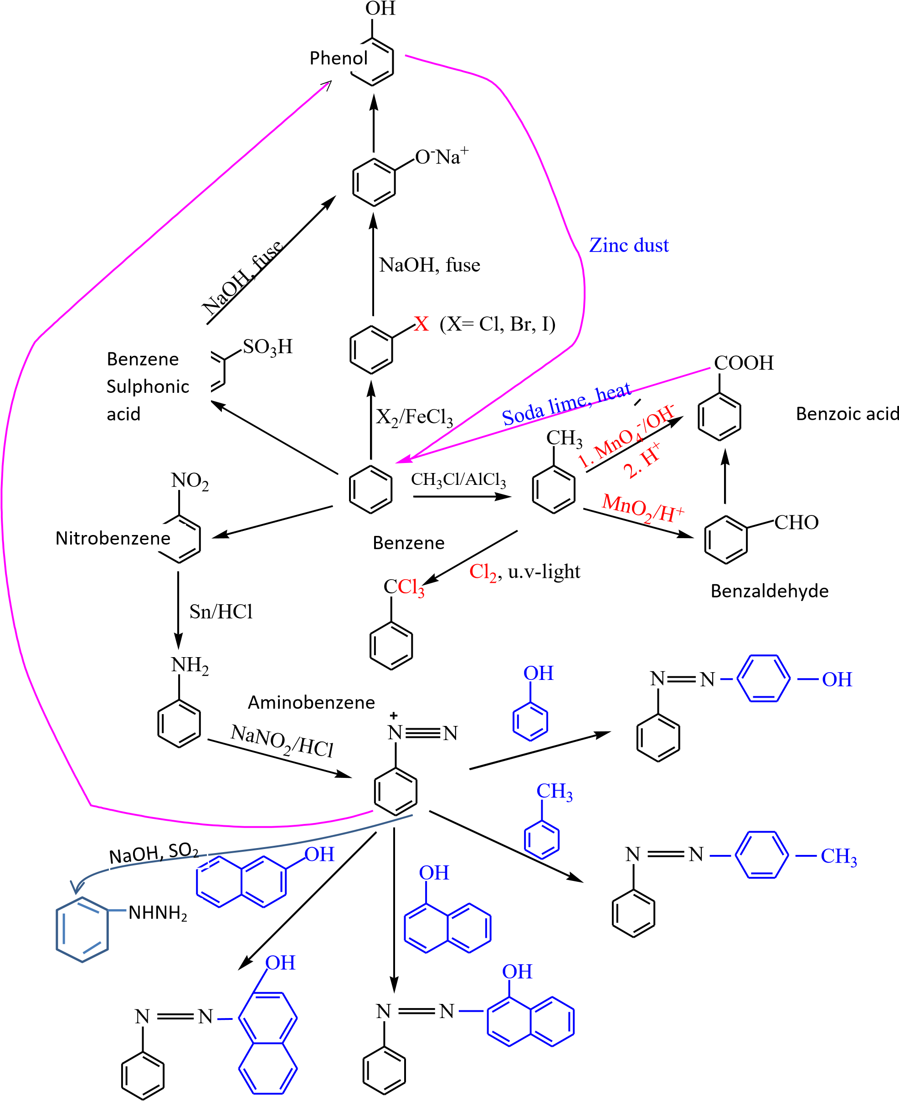

Nomenclature of derivatives of benzene with more than one substituent.
Number the carbon atoms on the ring and include the position(s) of the groups in the name.

Example 16
OH NO
2
2
1
Cl
1
2
3 NH₂
2-Chlorophenol 3-aminonitrobenzene
The prefixes; ortho, meta and para- usually abbreviated as o-, m-, and p- may be used for describing the relative positions of substituents in a di-substituted benzene.

Example 17
OH NO
2
3
2
1
Cl
1
2
NH₂
2-Chlorophenol 3-aminonitrobenzene
Or o-chlorophenol Or m-aminonitrobenzene

Effects of substituent group on the reactivity of the ring
A group attached to the benzene ring may have either of the two effects:
- Groups (such alkyl groups) that donate electrons to the benzene ring make the ring more reactive towards electrophilic substitution reaction
- Groups that donate electrons to the benzene ring like alkyl group that those with at least one lone pair of electron (-NH₂, -OH, Cl, Br) direct the incoming groups to position 2 or postion 4. For this reason they are described as 2, 4-directiong grousps

Example 18
e.g. sulphonation of methylbenzene.
CH₃ CH3 CH CH3
3
S
O
3
H
S
O
H
+ H₂SO₄
3
SO₃H
osu-tloplhuoenniec acid msu-ltpohluoennice acid psu-tloplhuoenniec acid
32% 6% 62%

Mechanism
H2SO4 H₂O + SO₃
Then,
CH CH3 CH₃
S
O
O
O
3
HSO₃H
SO₃⁻ proton
shift

Or
H
p
r
o
t
o
n
S
O
O
O
s
h
i
f
t
S
O
3
H
C
H
3
C
H
3
C
H
3
-
O
3
S

(iii) Groups that withdraw electron from benzene ring such as nitro or carboxylic groups, make the ring less reactive torwards electrophilic reagent. They the direct the incoming group to position 3 and are called meta directing groups.

Example 19

NO2 NO₂
+ H₂SO₄
SO3H

Preparation of phenol form cumene or 2-phenylpropane



CH
3

CH
3

CH
3
CH + O
2
(
g)

Cobalt naphthenate CH
3
H dil H
O

O

C

2
SO
4

OH

423
K (alkaline
medium)

The environmental and health impacts of benzene derivatives

Environmental impacts
- Air pollution: Benzene can react with other chemicals to form smog in the atmosphere.
- Water and soil contamination: Benzene can contaminate water and soil through spills, leaks, or atmospheric deposition via rain and snow.
- Ecological damage: Benzene and other hydrocarbons can directly harm aquatic organisms, damage habitats, and persist in sediments, leading to bioaccumulation in the food chain.
Health impacts
- Acute effects: Short-term exposure to high levels can cause headaches, dizziness, confusion, a rapid heart rate, and even death. It can also cause skin and eye irritation.
- Chronic effects: Long-term exposure can lead to serious health problems, including:
  - Blood disorders: A reduction in red and white blood cells, leading to conditions like aplastic anemia, anemia, and thrombocytopenia.
  - Cancer: Benzene is a known human carcinogen, and chronic exposure is linked to leukemia and other blood-related cancers.
  - Immune system damage: Exposure can weaken the immune system, making the body more susceptible to infection.
- Reproductive and developmental effects: Studies in pregnant animals have shown that benzene can cause low birth weight, delayed bone formation, and bone marrow damage. The effects on human reproduction are not fully understood but are a concern.

TOPIC 2/2: Equilibria I
Competency: The learner analyses principles of chemical equilibrium and applies them to explain and solve problems related to industrial processes, ionic equilibria, buffer systems, and solubility equilibria in various chemical and real-world contexts.

Chemical equilibrium
It is a branch of physical chemistry that deals with reversible reactions or reactions that proceed in either direction.

For example, when steam passed over heated iron, hydrogen and iron (II)diiron (III) oxide is formed. If, however, hydrogen is passed over heated iron (II) diiron (III) oxide, steam and iron are produced. Such reactions are said to be reversible and the equation for this reversible reaction is expressed as follows:

3Fe(s) + 4H₂O(g) → Fe₃O₄(s) + 4H₂ (g)

The direction of the reaction depends on the conditions: if hydrogen gas is removed as fast as it has formed, the reaction proceeds from left to right. Alternatively, if steam is removed as fast as it is formed the reaction will proceed from right to left.

By having steam and iron in a closed vessel, a state is reached at which all the four substance exist in equilibrium but the equilibrium in a balanced reaction is a dynamic one, that is, the substances are still reacting together except that the velocities of the forward and backward reaction are equal.

Equilibrium constant, Kc
The state of equilibrium of a reversible reaction at a given temperature is defined by equilibrium constant 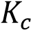 as follows
For a reaction
3Fe(s) + 4H₂O(g) ↔ Fe₃O₄(s) + 4H₂ (g)

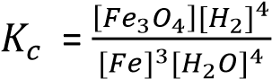

Where [ ] means concentration of the item in moles per litre or moles per dm³

For a general equation
aA + bB → cC + dD

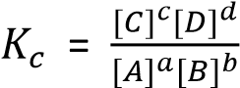
Units of Kc
The units of 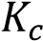 are derived by principles of dimension for instance

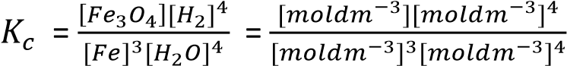
units = mol⁻²dm⁶

Trail 1
Write expressions for Kc for the following reaction and state their units
- N₂+ 3H₂ ↔ 2NH₃
- 2NH₃ ↔ N₂+ 3H₂
- N₂ + O₂ ↔ 2NO
- C₂H₅OH + HCl ↔ C₂H₅Cl + H₂O

Solution to trial 1
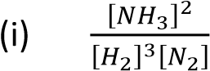 units = 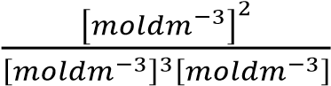 = mol⁻²dm⁶ 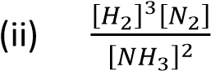 units = 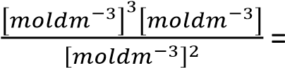 mol²dm⁻⁶ 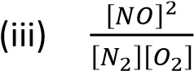 units = 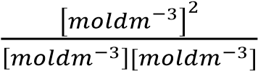= unitless 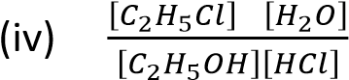 units = 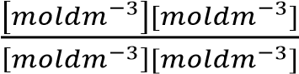= unitless

Implication of 
When 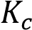 is high it implies that there are more products at equilibrium then the reactants
Application of equilibrium constant 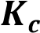
To calculate the amounts of the reactants and product at equilibrium

Summary of characteristics of equilibrium
- Occurs at constant temperature
- Occurs in closed system
- It is dynamic equilibrium

Example 1
Hydrogen reacts with iodine according to the following equation
H₂(g) + I₂(g) → 2HI(g)
A mixture of 0.8 moles of hydrogen and 0.6 moles of iodine was allowed to react in a sealed tube at 450⁰C at equilibrium 0.2 moles of iodine had reacted.
- Write the expression for the equilibrium constant, 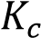 for the reaction
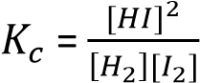
- Calculate the value of 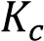(2marks)

First we calculate the moles at equilibrium mole of I₂ at equilibrium = 0.6 - 0.2 = 0.4 moles
Moles of H₂ at equilibrium
Mole of H₂ that reacted = moles I₂ that reacted
= 0.2moles
Thus, mole of H₂ at equilibrium = 0.8 – 0.2
= 0.6moles
Moles of HI at equilibrium
1 mole of I₂ that reacted produces 2moles of HI
0.2moles of I₂ produced 0.4mole of HI
Secondly, we substitute in 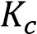 expression
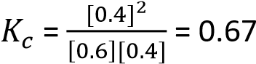

Example 2
- When 8.28g of ethanol were heated with 60g of ethanoic acid, 49.74g of the acid remained at equilibrium. Calculate 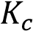
- What mass of ethylethanoate should be present in equilibrium mixture firmed from 13.8g of ethanol and 12g of ethanoic acid
Ethanol and ethanoic acid react as follow:
CH₃CH₂OH + CH₃COOH ↔ CH₃COOCH₂CH₃ + H₂O
ethanol ethanoic acid ethylethanoate water
(H= 1, C = 12, O = 16)

Solution
- Relative molecular mass of ethanol, CH₃CH₂OH = 46
Relative molecular mass of ethanoic acid, CH₃COOH | = 60
Initial moles of ethanol = 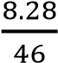 = 0.18moles
Initial moles of ethanoic acid = 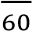 = 1moles

Final moles of ethanoic acid = 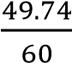 = 0.829 moles
From the reaction equation
Moles of ethanoic acid that reacted | = | Moles of ethanol that reacted | = | Moles of ethylethanoate that formed

Mole of ethanioic reacted = 1-0.829 = 0.171moles
Moles of water formed = moles of ethanoic acid reacted = 0.171moles
moles of ethanol that remained = 0.18- 0.171
= 0.009moles
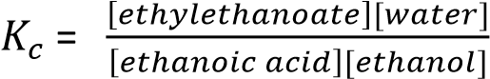
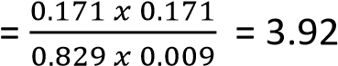
- 13.8g of ethanol = 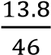 = 0.3moles
12g of ethanoic acid = 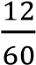 = 0.2moles
Let the mass of ethylethanoate that formed be x moles; employing for part (i)

3.92 = 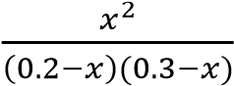
or 2.92x² -1.96x + 0.235 = 0
Using the general quadratic equation x = 0.514 or 0.158
The first value is inadmissible, since the number of moles of alcohol or acid which reacted cannot exceed the initial amount
Hence x = 0.158moles
Amount of ethylethanoate formed
= 0.158moles
or = 0.158 x 88 =13.9g

Trial 2
When 6.22moles of hydrogen were heated with 5.71moles of iodine in a sealed tube at 356⁰C it was found that 9.60moles of hydrogen iodide were present at equilibrium. Calculate
- the equilibrium constant
- the moles of hydrogen iodide in equilibrium mixture formed by heating 6.41moles of hydrogen and 10.40 moles of iodine at 356⁰C

Solution to trial 2

- H₂ (g) + I₂(g) ↔ 2HCl (g)
Initially 6.22 5.71 -
At equilibrium 1.42 0.91 9.60
Working
Mole of H₂ reacted 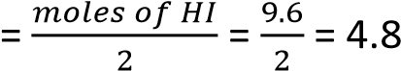
Moles of H₂ remained = 6.22 – 4.8 = 1.42moles moles of I₂ reacted = moles of H₂ reacted = 4.8moles moles of I₂ remained = 5.71 – 4.8 = 0.91moles

Kc = 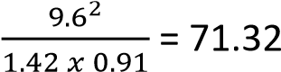
- Let the moles of HI formed be 2x
H₂ (g) + I₂(g) ↔ 2HCl (g)
Initially 6.41 10.40 -
At equilibrium (6.41-x) (10.40-x) 2x
Kc = 71.32 = 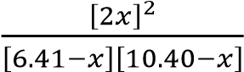
x = 5.96
Moles of HI = 5.95 x 2 = 11.92moles

Trial 3
Nitrogen reacts with hydrogen according to the following equation
N₂(g) + 3H₂ (g) ↔ 2NH₃(g)
- Write expression for equilibrium constant, 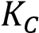
- Stoichiometric amounts of nitrogen and hydrogen were reacted in a 2litre vessel. At equilibrium,
0.8moles of ammonia was formed Calculate
(i) the amount of hydrogen at equilibrium (ii) the value of equilibrium constant,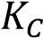.

Solution to trial 3

- 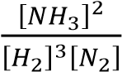
- Equation N₂(g) + 3H₂(g) ↔ 2NH₃
Initially 1 3 - Moles at equilibrium 0.6 1.8 0.8
Concentration at equilibrium 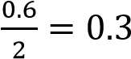 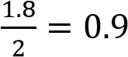 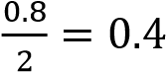
Working
Mole H₂ that reacted
2moles of NH₃ are formed by 3 mole of H₂.
0.8 moles of NH₃ are formed by 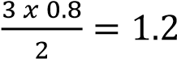
Moles of H₂at equilibrium = 3 – 1.2 = 1.8moles
Mole N₂ that reacted
1moles of NH₃ are formed by 3 mole of N₂.
0.8 moles of NH₃ are formed by 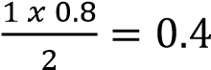
Moles of N₂at equilibrium = 1 – 0.4 = 0.6moles
Kc = 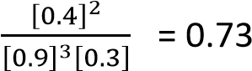

Trial 4
Hydrogen iodide decomposes when heated according to equation
2HI(g) ↔ H₂(g) + I₂ (g) ∆H +11.3kJmol⁻¹
- Write an expression for equilibrium constant, 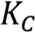 for the reaction (1mark)
- 1.54g of HI was heated in a 600cm³ bulb at 530⁰C. When equilibrium was attained, the bulb was rapidly cooled to room temperature and broken down under potassium iodide solution. The iodine formed from decomposition required 67.0cm³ of 0.1M sodium thiosulphate solution. Calculate
- the number of moles of HI in 1.54g (1mark)
- number of moles of iodine formed when hydrogen iodide decomposed (3marks)
- The value of 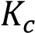
(c) State what would be the effect on 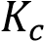 if
- the temperature was raised from 530⁰C to 800⁰C
- the volume of the bulb was increased to 1200cm³.

Solution to trial 4
- Kc = 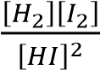
- (i) HI = 1+ 127 = 128
Moles = 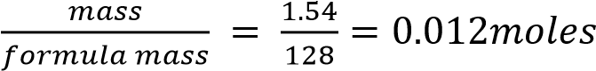
  - Mole of sodium thiosulphate = 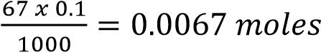
Moles of iodine =
Mole of hydrogen formed = moles of iodine = 0.00335 moles
Moles of HI decomposed = moles of iodine formed x 2 = 0.00335 x 2 = 0.0067 Moles of HI at equilibrium = 0.012 – 0.0067 = 0.0053
  - Kc = 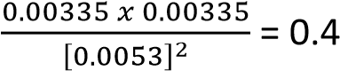
Since there is no change in number of moles of gas from left to the right, the volume of the container does not affect the value of Kc
- (i) Kc increases
  - Kc remains unchanged

Trial 5
1mole of H₂ and 1mole of I₂ were introduced into 2litre vessel at temperature at which the equilibrium constant is 55.3. How many moles of H₂, I₂ and HI are there after equilibrium has been established.

Solution to trial 5
Let the moles of HI = 2x
H₂(g) + I2(g) ↔ 2HI(g)
Initially 1 1 - At equilibrium 1-x 1-x 2x
Kc = 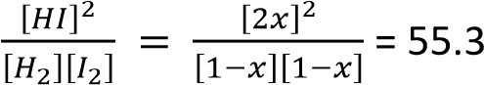
x = 0.79
Moles of H₂ = mole I₂ = 1- 0.79 = 0.21moles
Moles of HI = 2x = 2 x 0.79 = 1.58 moles

Trial 6
A reaction occurs according to the following Stoichiometric equation A + 2B ↔ 2C; 3moles of A and
5moles of B were brought together in a volume of 3litres and after equilibrium has been established,
1mole of A remained. Calculate the equilibrium constant 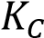 for the reaction. [48]

Trial 7
A reaction occurs according to the following Stoichiometric equation 2A + B ↔ 3C and has equilibrium constant of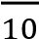. How many moles of B must be brought into contact with 5moles of A to produce at equilibrium 5moles of C.? [457]

Trial 8
5moles of ethanol, 6 moles of ethanoic acid, 6moles of ethylethanoate and 4moles of water were mixed together in a stoppered bottle at 15⁰C. After equilibrium had been attained the bottle was found to contain only 4 moles of ethanoic acid.
- (i) Write an equation for the reaction between ethanol and ethanoic acid to form ethylethanoate and water.
(ii) Suggest a mechanism for the reaction
- Write an expression for the equilibrium constant, for this reaction
- How many moles of ethanol, ethanoic acid, ethylethanoate and water are present in the equilibrium mixture?
- What is the value for 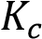 for this reaction
- Suppose 1moleof ethanol,1mole of ethanoic acid,3 moles of ethylethanoate and 3mole of water are mixed together in a stoppered flask at 15⁰C. How many moles of
  - ethanol,
  - ethanoic acid
  - ethylethanoate
  - water are present

Solution to trial 8
- (i)CH₃CH₂OH + CH₃COOH ↔ CH₃COOCH₂CH₃
- Kc = 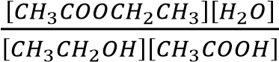
- Ethanol = 3, ethanoic acid = 4, ethylethanoate = 8, water = 6
- Kc = 4
- Ethanol = 1.33, ethanoic acid = 1.33, ethylethanoate = 2.67, water = 2.67

Equilibrium Constant in terms of, 
When at least one of the substances in equilibrium is gases, the state of equilibrium may be defined by equilibrium constant 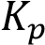 as follows For a reaction; aA(g) + bB(g) ↔ cC(g) + dD(g)
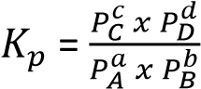
where , 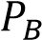, 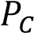,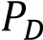 are the respective partial pressures of components A, B, C and D
and 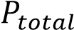 =+ + +
 = 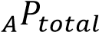
where 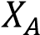 is mole fraction of A or the number of moles of component A over the total moles of components in the mixture and 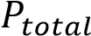 is the total pressure of the system.
Implications of 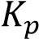
The bigger the value of 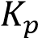 the higher the amount of product in the reaction mixtures
Application of 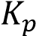
Like, is used to predict the proportion of the products and reactants at the equilibrium point in the mixture

Example 3
At 700⁰C and total pressure of one atmosphere the partial pressure at equilibrium for sulphur dioxide and oxygen are 0.27 and 0.41 atmospheres respectively. Sulphur dioxide is oxidized to sulphur trioxide according to the following equation
2SO₂(g) + O₂(g) ↔ 2SO₃ (g)
Calculate the equilibrium constant, 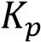, for the reaction (4marks)
Solution
Partial pressure of SO₃ = (1-(0.27 + 0.41)
= 0.32atm.
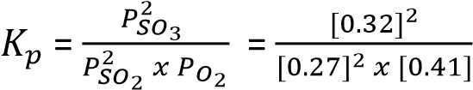= 3.46atm⁻¹

Trial 9
1mole of hydrogen iodide at 25⁰C was introduced into a container of 20 liters
- Calculate the pressure of the gas, assuming ideal behavior (1mole of a gas occupies 22.4dm³ under standard conditions).
- The sample of hydrogen iodide considered above was raised to a temperature of 300⁰C and partially decomposed into hydrogen and iodine gases; at equilibrium 0.1mole of iodine was found to be present
  - Write an equation for decomposition
  - Calculate the pressure of the equilibrium mixture at 300⁰C, assuming no volume change. (iii) Calculate the equilibrium constant at 300⁰C
- ∆H⁰_{f} HI = 26.5kJmol⁻¹. Explain giving reasons how you would expect the equilibrium constant to change with temperature.

Solution to trial 9

- From 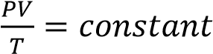
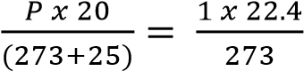=> P = 1.2 atmospheres
- (i) 2HI(g) ↔ H₂(g) + I₂ (g)
(ii) From 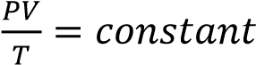
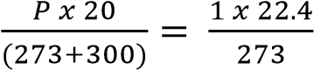=> P = 2.35 atmospheres
(ii) 2HI(g) ↔ H₂(g) + I₂ (g) Initially 1 - - At equilibrium 0.8 0.1 0.1
Total mole at equilibrium = 0.8 + 0.1 +0.1 = 1

P_{HI} = X_{A}P = 0.8 x 2.35 = 1.88 atmospheres
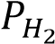 = 0.1 x 2.35 = 0.235 atmospheres
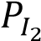 = 0.1 x 2.35 = 0.235 atmospheres

Kp = 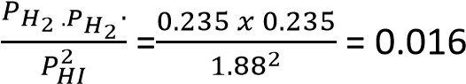
- Kp increases with increase in temperature because the reaction is endothermic.

Trial 10
Nitrogen reacts with hydrogen according to the following equation
N₂ (g) + 3H₂(g) ↔ 2NH₃(g)
- Write the equation for the equilibrium constant for the reaction in terms of partial pressure and indicate units (2marks)
- Stoichiometric amounts of nitrogen and hydrogen were reacted at 50atmospheres and at equilibrium, 0.8moles of ammonia were formed.
calculate
  - the amount of hydrogen at equilibrium (2½ marks)
  - The value of equilibrium constant for the reaction (4 ½ marks)

Solution ti trial 10
- Kp = 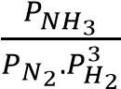 units: 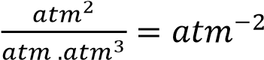
- (i) Equation N₂(g) + 3H₂(g) ↔ 2NH₃
Initially 1 3 -
Moles at equilibrium 0.6 1.8 0.8

Working

Mole H₂ that reacted
2moles of NH₃ are formed by 3 mole of H₂.
0.8 moles of NH₃ are formed by 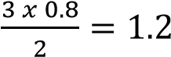
Moles of H₂at equilibrium = 3 – 1.2 = 1.8moles

Mole N₂ that reacted
1moles of NH₃ are formed by 3 mole of N₂.
0.8 moles of NH₃ are formed by 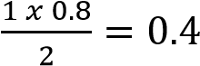
Moles of N₂at equilibrium = 1 – 0.4 = 0.6moles
(ii) Total moles of a gas at equilibrium = 0.6 + 1.8 + 0.8 = 3.2
From 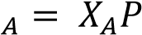
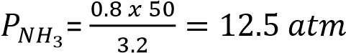
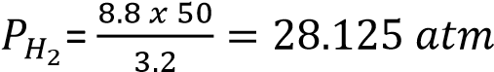
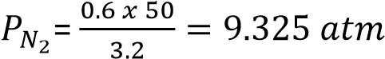
Kp = 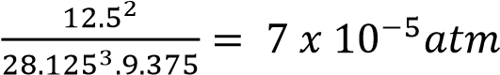

Trial 11
Consider the following reaction
H₂ (g) + I₂(g) ↔ 2HI (g)
At a certain temperature, analysis of an equilibrium mixture of the gases yielded the following results
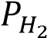 = 2.5 x 10⁻¹ atm.
= 1.6 x 10⁻¹ atm. 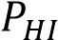 = 4.0 x 10⁻¹ atm.
- Calculate the equilibrium constant for the reaction and state its units.
- In second experiment at the same temperature, iodine and hydrogen were mixed together with each gas at a partial pressure of 3 x 10⁻¹atm. what are the partial pressures of hydrogen, iodine and HI at equilibrium?
- In the third experiment at the same temperature, pure hydrogen iodide was injected into the flask at a pressure of 6 x 10⁻¹atm. What are the partial pressures of hydrogen, iodine and hydrogen iodide at equilibrium?
- What effect, if any, will decreasing the temperature have on the value of ? Explain your answer.

Solution to trial 11

- Kp = 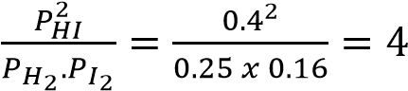
- 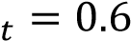

Partial pressure (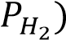of H₂ = partial pressure (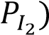 of I₂ at equilibrium ⇨ 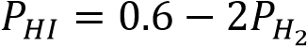
  - 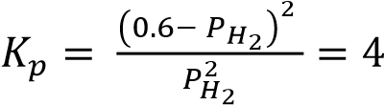
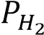 =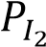 = 0.15atm
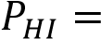 0.30atm
- 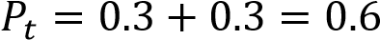

Partial pressure (of H₂ = partial pressure ( of I₂ at equilibrium ⇨
  - 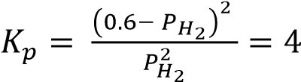
= = 0.15atm
0.30atm
- Decreasing temperature increases Kp because the reaction is exothermic

Trial 12
0.196g nitrogen and 0.146g hydrogen were heated together until equilibrium is established at a given temperature. The pressure found at equilibrium was found to be 90% its value at the beginning. Calculate the percentage composition by volume of the resulting mixture (H = 1, N = 14)

Solution to trial 12
Moles of N2 = 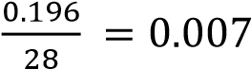
Mole of H2 = 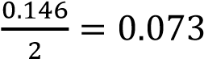
Total initial moles of a gas = 0.007 + 0.073 = 08moles
Let the mole so NH3 formed at equilibrium = 2x
Equation N₂(g) + 3H₂(g) ↔ 2NH₃
Initially 0.007 0.073 -
Moles at equilibrium 0.007 -x 0.073 -3x 2x
Total moles at equilibrium = 0.007 – x +0.073-3x + 2x = 0.08 -2x
Since pressure is proportional to the number of moles of a gas
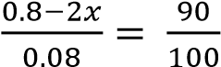
X = 0.004
%N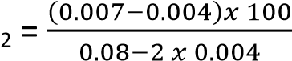 = 4.2%
%H₂ = 84,7%
%NH₃ = 11.1%

Trial 13
(a)(i) Nitrogen (II) oxide combines with O₂ at 80⁰C and 200atmosphere to form Nitrogen (IV) oxide according to equation
2NO (g) + O₂(g) ↔ 2NO₂(g), ∆H –xkJmol⁻¹
- Write an expression for the equilibrium constant for the reaction
- Calculate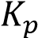, if the mixture contained 67% nitrogen (IV) oxide (3 ½ marks)
- State how the value of 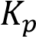 will be affected if
(i) Temperature is increased (ii) Catalyst is added
- The kinetic data for the reaction in (a) is shown in the table below
Initial rate/ Nm-2s-1 | 6.8 | 27.2 | 61.2 | 108
P2NO/N2M4 | 0.04 | 0.16 | 0.36 | 0.64
P_{NO} =the partial pressure of NO
- Plot a graph of initial rate against P²_{NO} (03mark)
- Using a graph, determine the order of reaction with respect to nitrogen II oxide
- Give a reason for your answer
(d) When the partial of O₂ was doubled to a new constant value, the gradient of the graph in C(i) doubles (i) Determine the order of reaction with respect to O₂. Explain your answer.
- Write the rate equation for the reaction in (d)
- Calculate the rate constant when the initial rate is 170Nm⁻²s⁻¹, P_{NO} = 0.1NM⁻², 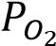 =1.36Nm⁻² PO₂
(e) State the effect of the following on the rate of the reaction
(i) Having partial of nitrogen II oxide while that of oxygen is kept constant (ii) Doubling partial pressure of both nitrogen II oxide and O₂.

Solution to trial 13

(a)(i) Kp = 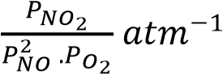
(ii) let the moles of NO₂ at equilibrium be 2x
2NO (g) + O₂(g) ↔ 2NO₂(g)
Initially 2 1 -
At equilibrium (2-2x) (1-x) 2x
Then, 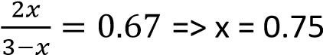
Total moles at equilibrium = 3- 0.75 = 2.25moles
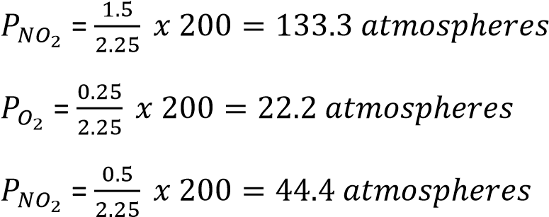
Kp = 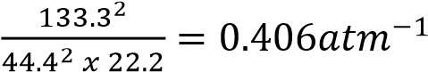
(b) (i) Kp decreases
(ii) Kp remain unchanged
(c)(i)
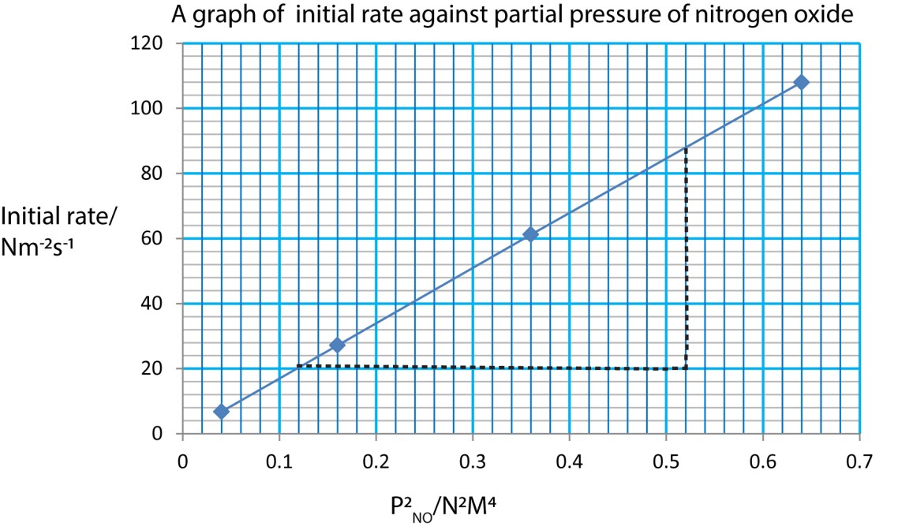
- 1st order
- Rate is proportional to concentration
(d)(i) 1st order the rate is proportional to concentration
- Rate = K[NO][O₂]
- K = 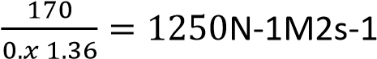
(e) (i) the rate halves
(iii) Rate is multiplied by 4

Relationship between  and 
We have already seen that equilibrium constants are normally expressed in term of concentration using the symbol and that, for reaction involving gases; it is usually convenient to express the amount of gases in terms of partial pressure rather than its molar concentration using the Ideal equation
PV = nRT
P = 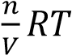
where p is the pressure in atmosphere, n is the number of moles, V, is the volume in cubic decimeter and T is the temperature in Kelvin. In this case R, the gas constant, has units are atmdm⁻³K⁻¹mol⁻¹ P = [gas]RT
Where [gas] is the concentration of the gas in moldm⁻³
Thus, at constant temperature, the pressure of a particular gas is proportional to concentration i.e. Pα [gas]
This means that for equilibrium H₂(g) + I₂(g) ↔ 2HI(g)
we can either write
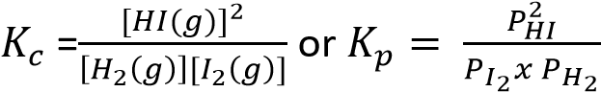
Now since = [HI(g)]RT
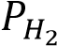 = [H₂(g)]RT
and 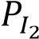 = [I₂(g)]RT
It follows that;
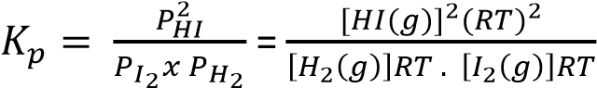
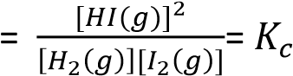
In this particular example 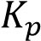 = and neither nor has units, but this is not always the case;
Consider another reaction
N₂(g) + 3H₂(g) ↔ 2NH₃(g)
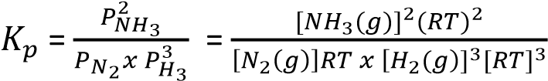
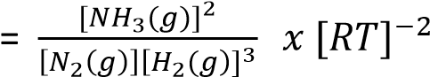
= 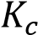(RT)⁻²
It implies that the numerical value of 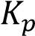 is the same as that of 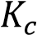 only where there are the same number of moles on each side of the Stoichiometric equation.
Although the SI unit of pressure is Nm⁻², it is standard practice to use atmospheres as pressure unit in expressing values. In general, = (RT)^{∆n} where ∆n = number moles on the right of the equation minus number of moles on the left.

Example 4
- Write an equation to show the relationship between the equilibrium constant, 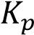 and partial pressure 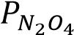 and 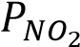 of the reactants in the following gaseous equilibrium N₂O₄ ↔ 2NO₂ ∆H (298k) = 54kJmol⁻¹ solution
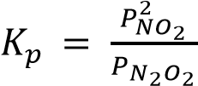
- State the effect, if any, on above equilibrium of
(i) increasing the pressure
Equilibrium shift from right to left leading to reduction in number of moles to fit in small volume. (ii) raising the temperature . Give reason for your answer.

Equilibrium shifts from left to right to reduce on the increase in temperature since the forward reaction is endothermic.
(c) It was found that one dm³ of the gaseous mixture weighed 2.777g at 50⁰C and pressure of 1.01 x 105 -2
Nm (1 atmosphere)
Calculate
(i) The fraction of N₂O₄ that dissociated solution
Moles of N₂O₄ initially = 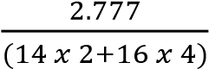
= 0.0302 moles
Moles at equilibrium
From ideal gas equation, PV = nRT n = 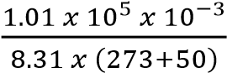
n = 0.03763 moles
If α is the fraction ionizes
Then
[1 mole of a gas occupies 22.4dm³ at s.t.p]
N₂O₄ ↔ 2NO₂ Initial moles, 0.0302 0
mole at equilibrium 0.0302(1-α) 0.0302(2α)
total moles at equilibrium
= 0.0302(1-α) + 0.0302(2α) = 0.03763mole
⇨ α = 0.25
Mole
- The percentage of NO₂ molecules in the mixture solution:
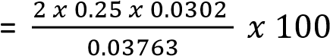= 40%
- The value of
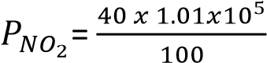= 40400Nm⁻².
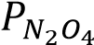 = 1.01 x 10⁵-40400 = 60600Nm⁻²
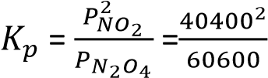= 2.69 x 10⁴ Nm⁻²

Factors affecting equilibriums these are 1. Temperature
- Pressure
- Catalyst
- Concentration
The effect of the above factors on equilibrium position for the equilibrium mixture can be explained qualitatively by Le Chatelier’s Principles that states that; ‘ if a system in equilibrium is subjected to a change, processes occur which tend to counteract the change imposed’.

Alternatively, ‘if the concentration of one of the reacting substance is altered, the equilibrium will shift in such a way as to oppose the change in concentration’

Effect of temperature
The effect of temperature on equilibrium depends on whether the reaction is endothermic or exothermic.
- For exothermic reactions (∆H⁰ negative) equilibrium position shifts to the left as temperature rise leading to a reduction in equilibrium constants
- for endothermic reactions (∆H⁰ positive) equilibrium position shift the right as temperature increases leading to increase in the value of equilibrium constants.
Alternatively, the direction of change is given by Vant Hoff’s Law of mobile equilibrium: “if a system is in equilibrium raising the temperature will favor that reaction which is accompanied by absorption of heat, and lowering temperature will favor that reaction which is accompanied by evolution of heat.
NB. It must be emphasized that it is only temperature that can alter the equilibrium positions and values of equilibrium constants among the factors states above whereas other factors alter only the equilibrium positions.

Effect of a catalyst
Catalysts have no effect on the equilibrium constants or 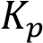 because they increase the rate of both forward and backward reaction in an equilibrium equally. However, they increase the rate at which equilibrium is attained.

Effect of concentration on equilibrium mixture
Variations in concentration of the reactant at constant temperature has no effect on the value of equilibrium constants 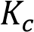 and. However, if the concentration of one of the reacting substance in a reversible equilibrium is altered, the equilibrium will shift in such away as to oppose the change in concentration.

Effect of pressure changes on equilibrium
- Pressure has appreciable effects when at least one of the reactant or product in a reversible reaction is a gas because unlike liquids and solids, gases are compressible.
- The effect of pressure on equilibrium where reactants and/or products are in gaseous form depends on whether there is change in the number of molecules of the gases as the reaction proceeds from left to right.
- In general, for gaseous reaction in which there is a change in the number of molecules, increase in pressure favors a reaction which produces fewer molecules or number of moles of the products.
- Pressure has no effect on those gaseous reactions in which there is no change in number of molecules as the reaction shifts from left to the right. e.g. H₂(g) + I₂ (g) ↔ 2HI(g)
- Generally high pressure increases the rate at which equilibrium is attained in gaseous mixture because it increases the rate of collision of the reacting molecules.
- Pressure has no effect on numerical values of and at constant temperature although the equilibrium concentration of reactants and product can vary over a wide range.

Example 5
Hydrogen reacts with nitrogen to produce ammonia according the following equation
3H₂(g) + N₂(g) ↔ 2NH₃(g)
- Write an expression for the equilibrium constant, (1mark)
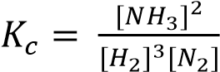
- State, giving reasons, what would happen to the value of the equilibrium constant when
  - Pressure is increased at constant temperature (3marks)
There will be no effect on the equilibrium constant because only temperature varies the value of the constant.
  - argon is added to the reaction mixture at constant pressure (2marks) There will be n effect on the equilibrium constant as long as temperature is constant.
(ii) Argon is added to the reaction mixture at constant volume (3marks)
This will increase pressure but there will be no change on the value of equilibrium constant of mixture because this value is not altered by pressure.

Trial 14
(a) Manganese sulphate reacts with acids according to the following equation
MnS(s) + 2H₃O⁺(aq) ↔ Mn²⁺(aq) + 2H₂O(l) + H₂S(aq)
State, giving a reason, what would happen to the equilibrium if
- Water is added to the equilibrium mixture (2marks)
- Hydrogen chloride is bubbled into the equilibrium mixture (2marks) (iii) pH of equilibrium mixture is increased.

Solution to trial 14
- Equilibrium shifts to the left to reduce the concentration of water added.
- Equilibrium shifts to the right to reduce the concentration of hydrogen ions.
- Equilibrium shifts to the left to produce hydrogen ions and lower the pH.

Trial 15
Ethanol decomposes according to the equation
CH₃CHO (g) ↔ CH₄(g) + CO(g) ∆H –ve
- Write an expression for the equilibrium constant, for the reaction
- Explain how 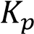 would be affected if
  - the temperature is increased
  - Pressure is increased

Solution to trial 15
- Kp = 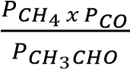
- (i) Kp decrease because increasing temperature shifts equilibrium from right to the left since the reaction is endothermic.
(ii) Kp remains unchanged since pressure has no effect on the value of Kp.

Trial 16
Phosphorous (V) chloride when heated decompose according to the following equation
PCl₅ (g) ↔ PCl₃(g) + Cl₂ (g)
A sample of pure phosphorus (V) chloride was heated in a closed vessel to 250⁰C. When equilibrium was attained the vessel was found to contain 40.7% chlorine
(a) Calculate
(i) the molar concentration of phosphorus (V) chloride at equilibrium (4 ½ marks)
(ii)the equilibrium constant for the reaction at 250⁰C (2 ½ marks)

Solution to trial 16
Let the mole of PCl₅ decomposed be x
PCl₅(g) ↔ PCl₃(g) + Cl₂(g)
Initially 1 - - At equilibrium 1 – x x x
Total moles = 1 – x + x + x = 1+x
%Cl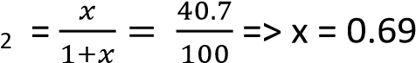
Mole of PCl5 at equilibrium = 1 – 0.69 = 0.31
Kc = 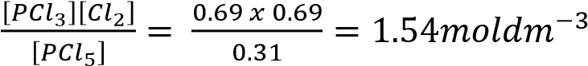

Trial 17
- Discuss the effect of each of the following on the position of a reversible reaction, the rate of at which the equilibrium is attained and the value of the equilibrium constant.
  - temperature (5marks)
  - pressure (7marks) (iii) atalyst (2marks)
- Write an expression for the equilibrium constant 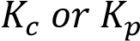 as appropriate to the following reactions at equilibrium and indicate units in each case
A + B ↔ C + 2D where under the conditions of experiment (i) A, B, C, and D are all gases.
  - A, B, C and D are all liquids
  - A, B, C are solids and D is a gas

Trial 18
- In the manufacture of methanol, carbon monoxide and hydrogen react according to the following equation
CO(g) + 2H₂(g) ↔ CH₃OH(g) ∆H -65kJmol⁻¹
  - State the optimum temperature and pressure for the reaction. Explain your answer (3marks)
  - Calculate the standard enthalpy of formation of methanol (standard enthalpy of formation of
Carbon monoxide = -108kJ) (2marks)
- (i) Write an expression for the equilibrium constant , (1mark) ii) At a certain equilibrium point, 15% of carbon monoxide had reacted. Calculate the pressure ( = 4 x 10⁻¹⁰kP⁻²)

Trial 19
During the manufacture of sulphuric acid by contact process, sulphur dioxide is oxidized to sulphur (VI) oxide according to the following equation.
2SO₂(g) + O₂(g) ↔ 2SO₃(g) ∆H = -188kJmol⁻¹
State the effect on the yield of sulphur (VI) oxide if
- Temperature was increased
- Pressure was decreased
- Concentration of sulphur dioxide was increased

Equilibrium in solution, Ka, Kb, Kw, Kh, Kin

Ionization of a weak acid
A weak acid is one that is partially ionized in water. For instance a weak acid HA will ionize in water as follow
HA (aq) + H₂O(l) ↔ H⁺(aq) + A⁻(aq)
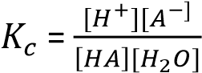
The concentration of H₂O is almost constant such that it can be incorporated in ti give another constant Ka
thus, 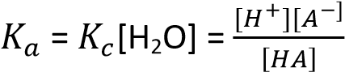

The greater the extent of dissociation, the greater are [H⁺] and [A-] in solution; the greater the Ka, and the stronger is the acid.

Alternatively, the strength of the acid is expressed in terms of pH. The ‘p’ in pH comes from the German word ‘potenz’ meaning power and ‘H’ from *H⁺]. The pH of solution is the negative logarithm to base ten of the molar concentration of hydrogen ions. i.e., pH = -log₁₀ [H⁺]

Example 6
The pH of 0.1M ethanoic (acetic) acid, CH₃COOH, is 3.40 at 25⁰C.What is the dissociation constant of ethanoic acid at this temperature?

Solution
Equation
CH₃COOH (aq) ↔ CH₃COO⁻(aq) + H⁺(aq)
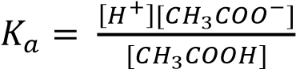
Since the concentration of H+ ions form water is much smaller that the concentration of those from acid; *H++ ≈ *CH₃COO⁻] = antilog-3.4
= 4.0 x 10⁻⁴moldm⁻³
and [CH₃COOH] = 0.01 – [H⁺+ ≈ 0.01
Thus, 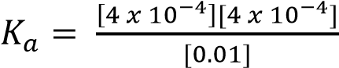
= 1.6 x 10⁻⁵moldm⁻³

Example 7
RCO₂H is a weak acid
- Write the equation for the ionization of the weak acid RCOOH in water (1mark) ans: RCOOH (aq) ↔ RCOO⁻(aq) + H⁺(aq)
- Write the expression for the ionization constant Ka, for the acid.
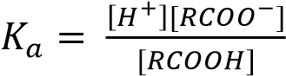
- Calculate the hydrogen ion concentration of 0.25M solution for the acid (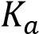 = 1.8 x 10⁻⁵) (4marks)

Solution
Let [H⁺] = x
Also, [H⁺] = [RCOO⁻] = x
[RCOOH] = [0.25 – x) ≈ 0.25 moldm⁻³, since the concentration of H+ is very small.
- 1.8 x 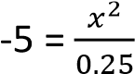10
- x = 2.12 x 10⁻³ moldm⁻³.
Concentration of H⁺ =2.12 x 10⁻³ moldm⁻³

Ionization of weak base
A base is a substance that abstracts a proton from water or dissociates in water to produce hydroxyl ion. Like weak acid, weak base are only partially dissociated in water.
B(aq) + H₂O(l) ↔ BH⁺(aq)+OH⁻(aq)
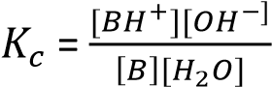
The concentration of H₂O is almost constant such that it can be incorporated in 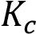 ti give another constant 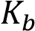

thus, 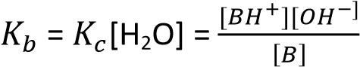

Like 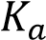, 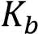, is a function of temperature, and the higher the 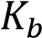 the stronger the base.

Example 8
- At 250C ammonia has a base ionization constant 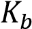 = 1.8 x10⁻⁵moldm³.
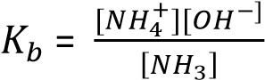
- Calculate the concentration of [–OH] in 0.1M ammonia solution at 25⁰C. state any assumption
Log [OH⁻] be x
Assumption: OH⁻ ions from ionization of water are negligible compared to those from ionization of ammonia
[OH⁻] = [NH₄⁺] = x
[NH₃] = (0.1 – x) 0.1 since x is very small
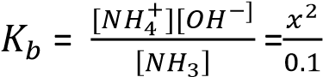= 1.8 x 10⁻⁵
⇨ 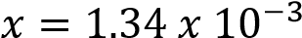 moldm⁻³

Dissociation of water
Water ionizes as follows
H₂O(l) ↔ H⁺(aq) + OH⁻(aq)
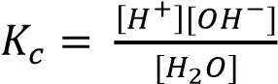
The concentration of H₂O is constant and is incorporated in the value of to give a new constant 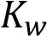.
Kw = [H⁺][OH⁻] 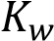 is ionic product for water, at 25⁰C pure water has Kw = 1 x 10 ⁻¹⁴ mol²dm⁻⁶.

Application of 
It is used to determine the pH of bases
Where [H+] = 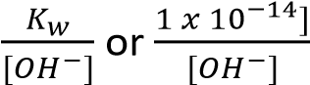

Example 9
Calculate the pH of 0.1M NaOH solution
Solution
Sodium hydroxide dissociate in water as follows
NaOH(aq) → Na⁺(aq) +OH⁻(aq)
[O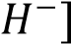 = [NaOH] = 0.1moles
[H+] = 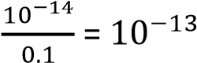
pH = -log[H⁺] = log[10⁻¹³] = 13

Buffers
These are solutions that resist changes in pH on addition of small amounts of either the acid or base.
Buffers are usually made of either a mixture of a weak acid and its salt with strong base (e.g. CH₃COOH +
CH₃COO⁻Na⁺) or a mixture of a weak base and its salt with a strong acid (e.g. NH₃ + NH₄Cl)

Mechanism of buffers
Consider a hypothetical weak acid, HA, in a solution with it salt MA. In this solution, HA, will be very slightly dissociated whilst MA is fully dissociated into ions;
HA (aq) ↔ H⁺(aq) + A⁻(aq)
MA(aq) → M⁺(aq) + A⁻(aq)
Hence the mixture contains a relatively high concentration of un-ionized HA (acid) and relatively high concentration of A⁻ (base)
If an acid is added to this system, the H⁺ ions in the acid will combine with A—ions to form HA thus removing nearly all the added H+ ions and keeping the pH relatively unchanged.
H⁺(aq) + A⁻(aq) → HA(aq)
When an alkali is added to a system, the added –
OH ions combine with the acid to produce water
HA(aq) + ⁻OH(aq) → H₂O(l) + A⁻(aq)
By having the reserves of HA and A- in buffer changes resulting from the addition of acid or alkali are minimized.

Calculating the pH of buffer solution
In a buffer composed of a weak acid HA and its salt MA
HA ↔ H⁺+ A⁻ and MA →M⁺+ A⁻
The expression for dissociation constant of HA is written as
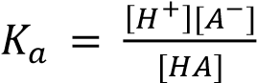 and [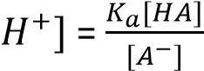
In the buffer mixture [HA] [acid] since the acid will be very slightly dissociated in presence of its salt and [A-+ ≈ *salt+ since the salt is fully dissociated
⇨ [H+] = 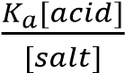
Introducing logarithms
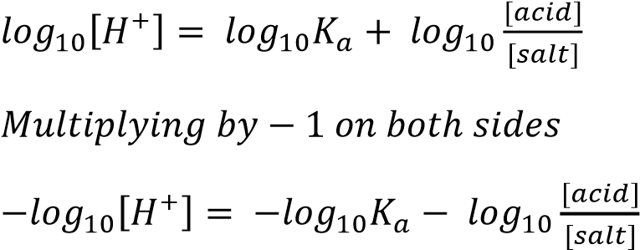
or pH = 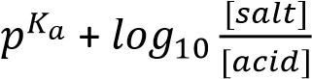
Similarly, a buffer composed of a weak base (e.g. NH₃) and its salt with a strong acid (e.g. NH₄Cl)
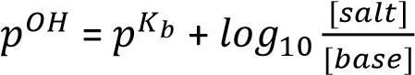
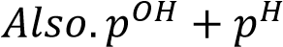 = 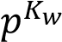 = 14

Example 10
Calculate the pH of the buffer made by adding 3.28g of sodium ethanoate to 1dm³ of 0.01Methanoic acid.
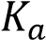(CH₃COOH =1.75 x 10⁻⁵moldm⁻³)
Solution
[Acid] = [CH₃COOH] = 0.01M
[Salt] = [CH₃COONa] =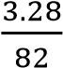 = 0.04M
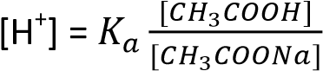= 1.7 x 10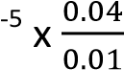
= 6.8x 10⁻⁵ moldm⁻³ pH = -log₁₀[H⁺] = 4.17

Hydrolysis of salts
It is the reaction of a salt with water to produce either acid or alkaline solution. The type of hydrolysis depends on the nature of salt.
(i) A salt formed by reacting a weak acid and a strong base hydrolyzes to give an alkaline solution. for example, sodium ethanoate is highly dissociated while water is very slightly ionized. The reaction occurs in solution as follows:
CH₃COO⁻Na⁺ →CH₃COO⁻ + Na⁺
then,
CH₃COO⁻(aq) + H₂O ↔ CH₃COOH(aq) + ⁻OH(aq)
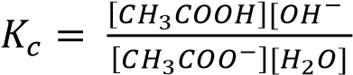
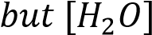 is almost constant
Thus, 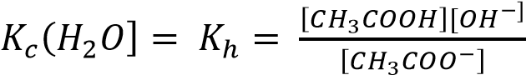
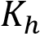 is called hydrolysis constant of a salt, the higher the K_{h} the more hydrolyzed the salt.

Expression of K_{h} in terms of Kw and Ka
Multiplying [H⁺] through the numerator and denominator give;
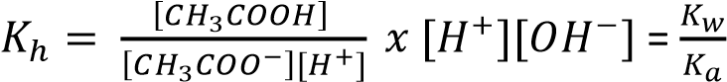

(ii) A salt of a weak base and a strong acid hydrolyzes in water to give acid solution e.g. NH4Cl dissociate in water as follows
NH₄⁺ + H₂O ↔ NH₃ + H₃O⁺
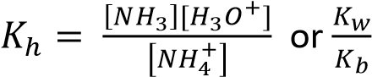

Example 11
Sodium benzoate undergoes hydrolysis when dissolved in water
(a) Write an equation for hydrolysis of sodium benzoate
C₆H₅COO⁻ (aq) + H₂O (l) ↔ C₆H₅COOH (aq) + OH⁻(aq) (b) Write an expression for the hydrolysis constant K_{h}.
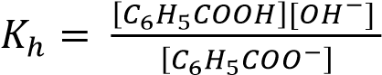
(c) The hydrolysis constant of sodium benzoate is 1.6 x 10⁻⁵moll⁻¹.
(i) Calculate the concentration of the hydroxide ions in a 0.10M sodium benzoate at 25⁰C (Kw = 1 x10⁻¹⁴ mol²dm⁻⁶) (4marks)

Solution
Let the concentration of OH⁻ ions be x
1.6 x 10⁻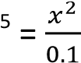
- x = 1.265 x 10⁻³moldm⁻³
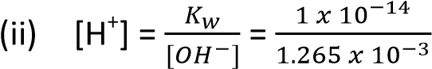= 7.9 x 10⁻¹²moldm⁻³
- pH = 11.1

(iii) State any assumption made in c(i) above
Hydrogen ions or hydroxyl ions from ionization of water are negligible

Solubility of sparingly soluble ionic solid in water
When a sparingly soluble salt such as silver chloride or barium sulphate, is added to water, a little dissolves and produces ions in solution. Equilibrium is established between the ions and the solid salt when the rate at which ions leave the crystal frame work of the solid is equal to the rate at which they are deposited again. Since the solubility is very small, the ions present in the liquid are few in number and are so far apart that they are free from mutual interference. We can therefore say that in the very dilute saturated solution the solution is completely dissociated.
With a solution of a sparingly soluble electrolyte AxBy in contact with the solid the dissociation can be expressed as follows
AxBy + aq ↔ xA^{y+} + yB^{x-}
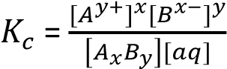
Since the salt is only slightly dissociated in water, the 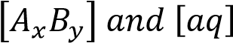are constant
thus, 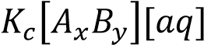 = 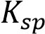 = 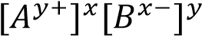
The constant 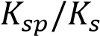 is the solubility product of the electrolyte, AxBy. The solubility product of a sparingly soluble electrolyte is the product of the concentration of ions in a saturated solution raised to corresponding Stoichiometric ration in the salt. The higher the 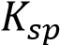 is the higher the solubility of the salt.

Example 12
The solubility of silver chloride at 18⁰C is 1.46 x 10⁻³gdm⁻³. What is the solubility product
(Ag =108, Cl = 35.5)

Solution
Note that in the calculation of solubility products the concentrations are expressed in moledm⁻³ or moll1

Mass of 1mole of AgCl = 108 + 35.5 = 143.5g
Solubility of AgCl = 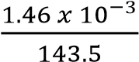 = 1.0 x 10⁻⁵moldm⁻³
Since one ‘molecule’ of silver chloride furnishes on dissociation one Ag⁺ ion and one Cl⁻ ion, and since the dissolved silver chloride is completely dissociated in ions
= [Ag⁺][Cl⁻] = (1 x 10⁻⁵)(1 x 10⁻⁵)
= 1 x 10⁻¹⁰mol²dm⁻⁶

Example 13
The solubility of calcium hydroxide in water at 20⁰C is 2.78gdm⁻³. What is the solubility product? (Ca = 40, O = 16, H = 1)

Solution
Molarity of Ca(OH) 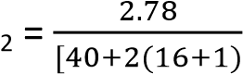= 0.0376moldm⁻³
[Ca²⁺] = 0.0376moldm⁻³
[OH⁻) = 2 x 0.0376 = 0.0752moldm⁻³
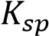 = [Ca²⁺][OH⁻]² = 0.0376 x (0.0752)²
= 2.13 x 10⁻⁴mol³dm⁻⁹

Limitation to the solubility product concept
- Salts like potassium nitrate of relatively high solubility, do not possess solubility products because the law of mass action does not hold in their case. The solubility product concept is only valid for saturated solution in which the total concentration of ions is no more than about 0.01M
- The solubility product constant, like all other equilibrium constants change with temperature; consequently, the temperature at which solubility product is measured should always be specified unless it relates to the standard temperature of 298K or 25⁰C.

Application of solubility product concept

(a) The common ion effect
This is the reduction in the solubility of a sparingly soluble salt in a solution in which it has a common ion.
Although the solubility product of a particular salt is constant at a constant temperature, the concentrations of the individual ions may vary over a very wide range. When a saturated solution is obtained by dissolving the pure salt in water the concentration of the ions produced are in the ratio determined by the stoichiometry of the compound. E.g. concentration of Ag⁺ and CrO₄²⁻ ions in pure saturated silver chromate solution must be in ration 2:1. However, when a saturated solution is obtained by mixing two solutions containing a common ion (such as Ag₂CrO₄ and AgNO₃) there may be a big difference in the concentration of ions of any sparingly soluble electrolyte. In this case, the solubility product is used to determine the concentration of the ions in solution.

Example 14
Calculate the solubility of BaSO₄ in (i) Water?
(ii) in 0.1M sodium sulphate solution?
(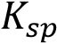 = 1 x 10⁻¹⁰mol²dm⁻⁶)

Solution
- BaSO₄ dissociate as follows
BaSO₄(s) ↔ Ba²⁺(aq) + SO₄²⁻(aq)
Let the solubility be x
[Ba²⁺] = [SO₄²⁻] = x
= [Ba²⁺][SO₄²⁻] = x² = 1 x 10⁻¹⁰ ⇨ x = 1 x 10⁻⁵moldm⁻³.
Solubility of BaSO₄ in water = 1 x 10⁻⁵moldm⁻³
- Let the solubility of BaSO₄ in 0.1M Na₂SO₄ be y
Na₂SO₄(s) dissociates as follows
Na₂SO₄ (aq) → 2Na⁺(aq) + SO₄²⁻(aq)
[Ba²⁺] = y
[SO₄²⁻] = (0.1 + y)
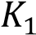= y(0.1+y) = 1 x 10⁻¹⁰ y is very small that (0.1+y) 0.1 thus 0.1y = 1x10⁻¹⁰
y = 1 x 10⁻⁹moldm⁻³
Solubility of BaSO₄ in 0.1M Na₂SO₄ = 1 x 10⁻⁵moldm⁻³
This example illustrate that BaSO4 is more soluble in water than in NaSO4 solution that contains a common ion (i.e. SO₄²⁻)

(b) Prediction of Precipitation
The solubility product is used to predict the maximum concentration of ions in solution at a given temperature and hence whether or not precipitation will occur.
Suppose we mix 0.001M CaCl₂ solution (which contains 0.001M Ca²⁺ ions) with equal volume of 0.001M Na₂SO₄ (i.e. 0.001M SO₄²⁻ ions) solution at 25⁰C. Will a precipitate of CaSO₄ formed? (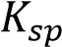 CaSO4 = 2 x 10⁻⁵mol²dm⁻⁶)
Immediately after mixing equal volumes of the two ions and before any precipitation
[Ca²⁺] = [SO₄²⁻] = 5 x 10⁻⁴M
(i.e. the concentration of each ion is halved since each solution is diluted by mixing with the other). Hence the ionic product for CaSO₄ immediately after mixing
[Ca²⁺][SO₄²⁻] = 5 x 10⁻⁴ x 5 x 10⁻⁴ = 2.5 x 10⁻⁷mol²dm⁻⁶
This ionic product is less than the value of 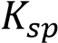 for CaSO₄ and so no precipitation occurs.
Let ionic now suppose that we mix equal volumes of 0.01M solution of each. Immediately after mixing
[Ca²⁺] = [SO₄²⁻] = 5 x 10⁻³M and ionic product
[Ca²⁺][SO₄²⁻] = 5 x 10⁻³ x 5 x 10⁻³
= 2.5 x 10⁻⁵mol²dm⁻⁶
In this case, the ionic product is greater than the solubility product and therefore precipitation of CaSO₄ occurs. The concentration of aqueous Ca²⁺ and SO₄²⁻ ions are lowered by the reaction. Ca²⁺ (aq) + SO₄²⁻(aq) → CaSO₄ (s)
Coral reef, stalagmite and stalactites are result of slow precipitation of CaCO₃ from water when concentration of Ca²⁺ and CO₃²⁻ exceed the 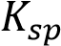 of CaCO₃.

(c) Selective precipitation
This is used to separate salts with different solubility,. e.g. Ca²⁺, Mg²⁺ and Ba²⁺ can be separated by adding K₂Cr₂O₄(aq), which precipitate out BaCrO₄ (which is the least soluble) and removed by filtration. The remaining solution that contain Mg²⁺ and Ca²⁺ is then separated by adding Na₂SO₄ that precipitate out CaSO₄ (CaSO₄ in less soluble than MgSO₄) leaving Mg²⁺ in solution

Note that the order in which reagents are added is important. If we had added Na₂SO₄ solution before adding K₂CrO₄ solution a mixture of BaSO₄ and CaSO₄ would have been precipitated.

On the other hand, if Na₂CO₃ solution had been added to the mixture of the three cations; MgCO₃, CaCO₃ and BaCO₃ would all have been precipitated. Thus, both the precipitating reagent and the order of addition must be selected with great care.

(d) Use of potassium chromate (VI) in silver nitrate titration
When silver nitrate solution is titrated with sodium chloride solution containing a little potassium chromate (VI) only silver chloride is precipitated as long as there are any chloride ion in solution.
Only when all chloride ions have reacted doe a red precipitate of silver chromate (VI) appear. This is explained by the solubility products of the two silver salts; i.e. (Ag⁺)(Cl⁻) = 1 x 10⁻¹⁰mol²dm⁻⁶ while (Ag⁺)₂(CrO₄²⁻) = 2.5x 10⁻¹²mol³dm⁻⁹. Suppose the concentration of Cl⁻ and CrO₄²⁻ ions in the liquid are both 0.1M. Then
[Ag⁺] needed to precipitate silver chloride
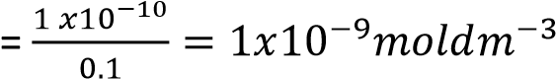
[Ag⁺] needed to precipitate silver chromate
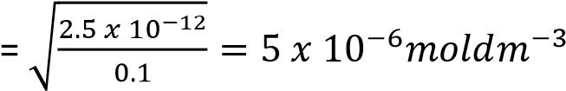
Thus even if the concentration of the Cl⁻ ions and CrO₄²⁻ ions in the liquid are equal, it is easier by adding Ag⁺ ions to reach the solubility product of the chloride than that of the chromate (VI) in spite of the lower solubility product of the latter. In practice [Cl⁻] is much larger than [CrO₄²⁻]. Hence silver chloride I precipitated even more readily.

Indicators
Acid-base indicators are substances which change color according to the hydrogen ions concentration of the liquid in which they are placed. They are either weak acids or weak bases, and are therefore slightly dissociated when dissolved in water. The color of the indicator depends on the color of the undissociated molecules and the color of the ions produced. Taking methyl orange as an example, dissociation occurs as follows:

More precisely

(CH₃)₂N SO₃H H+ + (CH₃)₂N SO₃-
N
2
N
2

RED YELLOW
When a drop of methyl orange is added to water, the resultant color is orange. if now an acid is added, the hydrogen ions of the acid drive back the ionization of methyl orange, very few Me⁻ ion remain, and the indicator becomes pink. Alternatively, addition of a base provides a large concentration of hydroxyl ions which combine with the H⁺ of the indicator to form water. More of the indicator ionizes and a large concentration of Me⁻ ions are produced, giving a yellow color. similarly, litmus has red HA and blue A⁻ ions.

Neutrality/ End point of indicator
The aim of any titration is to determine the volume of two solutions that just react with each other. Thus, the end point which is the point at which the titration is stopped, must coincide with equivalence point for the two reacting solutions.

In order to achieve this, the indicator should change color sharply at equivalent point on addition of a single drop of either acid or alkali. At the exact end point of the titration, the color of the indicator will be midway between the acid color HIn and the color of In⁻ . If the dissociation constant of the indicator
is represented by 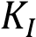, then 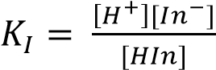, or [H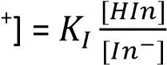
When the color of HIn and In- are equal,
[HIn] = [In⁻] so [H⁺] = 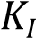
or pH = -log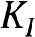 = p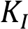

Range of an indicator
Every indicator has a definite range of pH over which it changes color given by pH range = p 1

The colors and pH ranges of some common indicators are given in the table below:
Indicator | pH range | acid | alkali
Thymol blue | 1.2-2.8 | red | yellow
Methyl orange | 2.9-4.6 | pink | yellow
Congo red | 3.0-5.0 | blue
Methyl red | 4.2-6.3 | pink | yellow
Litmus | 5.0-8.0 | red | blue
Phenolphthalein | 7.4-9.0 | colorless | red

PH change during titration
During a titration, there is a change in pH as alkali is added to acid or vice versa. At the equivalent point, the pH must change sharply by several units for it to be identifiable using an indicator.

The change in ph during the course of a titration depends largely upon the strength of the acid and alkali used.
The figure shows the effect on pH value of adding to 50cm³ molar HCl (strong acid) increasing quantities of molar solution of NaOH and secondary, a solution of NH₃ (a weak base)
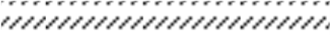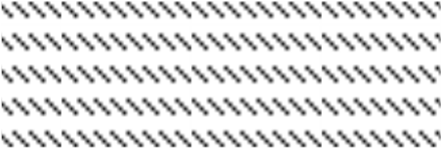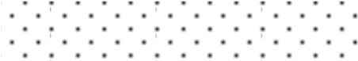

12

11

10

9

8

7

6

5

4

3

2

pH

52
50 51
49

Volume of alkali/cm
3

Ph
enolphthalein

range

L
itmus range

methyl
orange range

NH
3

N
aOH

Figure 1

Note that, with NaOH addition of a very small volume of the base near the end point provides a very large change in the hydrogen ions concentration almost completely covering the pH ranges of methyl orange, litmus and phenolphthalein; In practice any of these indicator may be used during a titration of a strong acid with a strong base.

With ammonia solution adding a small amount of base near end point produces a small change in hydrogen ion concentration, and the end point is less sharp, no matter what indicator is used; although methyl orange provides the best choice.

The effect on pH value of adding tocm3 of molar ethanoic acid (weak acid) increasing quantities of first molar NaOH solution (strong base and secondly, molar ammonia (weak base) is illustrated in figure below

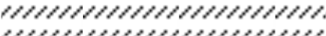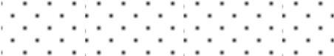

Figure 2

NH
3

NaOH

Phenolphthalein

range

L
itmus range

methyl
orange range

12

11

10

9

8

7

6

5

4

3

2

pH

49
50 51
52

Volume of alkali/cm
3

In the first case a less sharp end point that with a strong acid and strong base is again obtained with phenolphthalein as the best indicator for this titration. When the acid and the base are both weak, the end point is so indefinite that in practice a weak acid and weak base are never titrated against each other.

Choice of indicator
The true end point of neutralization in any titration occurs when the amount of acid and base added together are chemically equivalent to each other. The solution may not have a pH (i.e. neutral) equal to that of water at this point. With strong acids and strong base the final pH is about 7. In other cases hydrolysis of salt takes place, producing a pH greater or less than 7. Thus according to figure 1, the pH is about 5 for 0.5M NH4Cl solution and from figure 2 about 9 for a 0.5M solution of sodium ethanoate (CH₃COONa).
For a strong acid and a strong base the theoretically correct indicator is litmus, but in practice both methyl orange and phenolphthalein can be used. Similarly, methyl orange (or more accurately methyl red) is the correct indicator for titrating aqueous ammonia and hydrochloric acid, and phenolphthalein for sodium hydroxide and ethanoic acid. The general rules for indicators can be summarized as follows:
Strong acid and strong base – any indicator
Strong acid and weak base – methyl orange
Weak acid and strong base – phenolphthalein
Weak acid and weak base are not titrated.

